UCS 1611 - Internet Programming Lab **Exercise 4: Java Servlets and MySQL**

**Swetha Saseendran**

**CSE-C**

**185001183**

**Learning objective:**

1. **Read form details and calculate gross pay:**

To write a servlet program which reads all form details, finds the gross pay based on basic pay and designation. The servlet returns all details (a-j, gross pay) in table format to the client.

* 1. Employee ID
  2. Employee Name
  3. Designation
  4. Department
  5. Basic Salary
  6. Phone Number
  7. Address
  8. Date of Birth
  9. Gender
  10. Marital Status
  11. Submit (Button, onclick submit the form details to a servlet)
  12. Reset (Button, onclick)

1. **Patient Management System**

To develop a Patient Management System (PMS) in a Hospital that maintains the patient records such that:

* 1. Admin only can access the patient records.
  2. Admin has to authenticate himself with the credentials to access the patient details.
  3. The first page is the login page (login.html) where the admin should enter the credentials .
  4. If login fails, display an alert “Login Failed, enter the correct details”, clear the username and password textbox and focus the control back to the username of login.html
  5. Perform the authentication using JavaScript, use hardcoded username and password in login.html
  6. On successful login, it should be redirected to homepage (homepage.html) of PMS with links to add/update/search/delete record and view records.
  7. Clicking the links should invoke its corresponding html file from where the information is submitted to the corresponding Servlet.
  8. Similarly, perform ADD, UPDATE, VIEW and SEARCH using corresponding html and Servlet.
  9. UPDATE is invoked if phone number or Address of the patient is changed.
  10. SEARCH for particular patient based on Patient ID.
  11. After each operation ViewServlet should be invoked to view the changes in the Database

**Code- Calculate Gross Pay:**

**index.html**

<!DOCTYPE HTML>

<html>

   <head>

      <title>Employee Registration Form</title>

      <!-- Stylesheet -->

      <link href="style.css" rel='stylesheet' type='text/css' />

   </head>

   <body>

      <!--background-->

      <h1>Employee Registration Form </h1>

      <div class="register-form">

         <!-- Form starts here -->

         <form id="employee_form" name="employee_form" action="ServletOne" method="GET">

            <div class="main">

               <div class="field-text1">

                  <input type="text" id="emp_name" name="emp_name" placeholder="Employee Name"

                     minlength="6" required>

               </div>

               <div class="field-text1">

                  <input type="text" id="emp_id" name="emp_id"  placeholder="Employee ID">

               </div>

            </div>

            <div class="main">

               <div class="field-text1">

                <select class="form-control" id="dept" name="dept" style="width: 50%;">

                    <option>Department</option>

                    <option value="Thoracic Surgery">Thoracic Surgery</option>

                    <option value="General Surgery">General Surgery</option>

                    <option value="Neurological Surgery">Neurological Surgery</option>

                    <option value="Orthopaedic Surgery">Orthopaedic Surgery</option>

                 </select>

               </div>

               <div class="field-text1">

                <select class="form-control" id="desig" name="desig" style="width: 50%;">

                    <option>Department</option>

                    <option value="Chief">Chief</option>

                    <option value="Attending">Attending</option>

                    <option value="Resident">Resident</option>

                    <option value="Intern">Intern</option>

                 </select>

             </div>

             <div class="field-text1">

                <input type="text" id="basic" name="basic" placeholder="Basic Salary" required="">

             </div>

               <div class="field-text1">

                  <input type="text" id="Phone" name="Phone" placeholder="Phone Number"

                     minlength="10" required>

               </div>

            </div>

            <div class="main">

               <div class="field-text1">

                  <input type="date" id="DOB" name="DOB" value="DOB" style="width: 50%;" min="2000-01-01" max="2015-12-31" required>

               </div>

            </div>

            <div class="radio-section" required>

               <h6>Gender</h6>

               <ul class="radio-buttons">

                  <li>

                     <input type="radio" id="male" name="selector2">

                     <label for="a-option">Male</label>

                     <div class="check"></div>

                  </li>

                  <li>

                     <input type="radio" id="female" name="selector2">

                     <label for="b-option">Female</label>

                     <div class="check">

                        <div class="inside"></div>

                     </div>

                  </li>

                  <li>

                     <input type="radio" id="other" name="selector2">

                     <label for="b-option">Other</label>

                     <div class="check">

                        <div class="inside"></div>

                     </div>

                  </li>

               </ul>

               <div class="clear"></div>

            </div>

            <div class="main">

               <div class="field-text1">

                  <select class="form-control" id="Marital" name="Marital" style="width: 50%;" onchange="marStatus()">

                     <option>Marital Status</option>

                     <option value="Single">Single</option>

                     <option value="Married">Married</option>

                     <option value="Divorced">Divorced</option>

                  </select>

               </div>

            </div>

            <div class="field-text1">

               <textarea name="Message" id="Address"  name="Address" placeholder="Address..."></textarea>

            </div>

            <input type="submit" id="Submit" name="Submit" value="submit">

            <input type="reset" value="Clear Form">

            <div class="clear"></div>

         </form>

      </div>

      <!--copyright-->

      <div class="copyright">

         <p>&copy; 2021 Doctor Registration Form | All Rights Reserved</p>

      </div>

      <!-- Java Script-->

      <script src="js/index.js"></script>

   </body>

</html>

**style.css**

html,body,div,h1,h2,p,img,section

{

    display: block;

}

a

{

    text-decoration: none;

}

.clear

{

    clear: both;

}

img

{

    max-width: 100%;

}

body

{

    font-family: 'Source Sans Pro', sans-serif;

    font-size: 100%;

    background: url(emp.jpg)no-repeat center top;

    background-size: cover;

    background-position: center;

}

.register-form

{

    box-sizing: border-box;

    padding: 3vw;

    background: rgba(0, 0, 0, 0.78);

    max-width: 700px;

    margin: 0 auto;

}

h1

{

    font-size: 4vw;

    margin: 3.5vw 0vw 2vw;

    font-weight: 300;

    color: #fff;

    text-shadow: 3px 3px 3px #1d1d1d;

    letter-spacing: 5px;

    text-align: center;

    font-family: 'Source Sans Pro', sans-serif;

}

h2.sub-heading,

h3.sub-heading

{

    text-align: center;

    font-size: 24px;

    color: #23b4cc;

    margin-bottom: 14px;

    font-weight: 300;

    letter-spacing: 2px;

    background: rgba(255, 255, 255, 0.05);

    border-radius: 50px;

    box-shadow: 2px 2px 20px rgba(0, 0, 0, 0.86);

    font-family: 'Source Sans Pro', sans-serif;

}

/*-- form --*/

#addict li

{

  color: #23b4cc;

  appearance:button;

  display: inline-block;

  padding: 2px 5px;

  background-color: black;

  border-radius: 25px;

}

input[type="date"]::-webkit-calendar-picker-indicator

{

    color: black;

    display: block;

    background-color: white;

    opacity: 0.5;

    width: 20px;

    height: 20px;

    border-width: thin;

}

.radio-section

{

    text-align: left;

    margin: 0.7em 0;

}

.radio-section h6

{

    display: inline;

    color: #82bb3b;

    font-size: 18px;

    font-weight: 400;

    letter-spacing: 1.5px;

    font-family: 'Source Sans Pro', sans-serif;

}

.radio-section ul

{

    display: block;

}

.radio-buttons li input[type="radio"]

{

    cursor: pointer;

}

.radio-buttons li label

{

    color: #23b4cc;

    font-size: 15px;

    font-weight: 600;

    letter-spacing: 1px;

    font-family: 'Source Sans Pro', sans-serif;

}

.register-form input[type="text"],

.register-form input[type="email"],

.register-form textarea,

select.form-control,

input

{

    width:100%;

    font-weight: 300;

    color: #fff;

    font-size: 16px;

    letter-spacing: 1.2px;

    padding: 10px 10px;

    outline: none;

    background: rgba(255, 255, 255, 0);

    border: none;

    border-bottom: 1px solid rgba(255, 255, 255, 0.27);

    box-sizing: border-box;

    font-family: 'Source Sans Pro', sans-serif;

}

.register-forms textarea

{

    resize: none;

    height: 100px;

}

.field-agileinfo-spc

{

    margin-bottom: 1em;

}

.form-w3-agile-text

{

    width: 100%;

}

select.form-control option

{

    background: #000;

}

.register-form input[type="submit"],

.register-form input[type="reset"]

{

    text-transform: capitalize;

    background: #23b4cc;

    color: #fff;

    padding: 0.5em 1em;

    border: none;

    width: 48%;

    margin-top: 1em;

    float: left;

    outline: none;

    font-family: 'Source Sans Pro', sans-serif;

}

.register-form input[type="reset"]

{

    float: right;

}

.register-form input[type="submit"]

{

    background: #23b4cc;

}

.register-form input[type="submit"]:hover

{

    background: #82bb3b;

    color: #fff;

}

.register-form input[type="reset"]:hover

{

    background: #82bb3b;

    color: #fff;

}

.register-form ::-webkit-input-placeholder

{

    color: #fff;

}

.register-form label

{

    font-size: 13.5px;

    color: rgba(255, 255, 255, 0.83);

    letter-spacing: 2px;

    font-weight: 400;

    position: relative;

    margin-bottom: 5px;

    display: inline-block;

    text-transform: capitalize;

}

ul.radio-buttons li

{

    display: inline-block;

    margin: .8em 2em 0em .3em;

}

.copyright

{

    margin: 2em 1em;

    text-align: center;

}

.copyright p

{

    color: #fff;

    font-size: 16px;

    letter-spacing: 1.5px;

    text-shadow: 1px 1px 2px #000;

    font-weight: 400;

}

/*DISPLAY PAGE*/

.display_cont

{

    box-sizing: border-box;

    padding: 3vw;

    background: rgba(0, 0, 0, 0.78);

    max-width: 700px;

    margin: 0 auto;

    width:fit-content;

    border-radius: 25px;

}

h2,h3

{

  font-family: 'Source Sans Pro', sans-serif;

  letter-spacing: 1.5px;

  color: white;

}

.text_box

{

  color: #23b4cc;

**ServletOne.java**

import java.io.*;

import jakarta.servlet.*;

import jakarta.servlet.http.*;

public class ServletOne extends HttpServlet {

    public void doGet(HttpServletRequest request, HttpServletResponse response)

       throws ServletException, IOException {

       // Set response content type

       response.setContentType("text/html");

       PrintWriter out = response.getWriter();

       String title = "Grey Sloan Memorial Hospital";

       String welcome = "Welcome "+request.getParameter("emp_name") +"!";

      int basic = Integer.parseInt(request.getParameter("basic"));

      int gross = 0;

      int hra=0,oa=0;

      String desig = request.getParameter("desig");

      // Calc Gross pay: Gross = Basic + HRA + Other Allowances

      if(desig.equals("Chief"))

      {

         hra = 50000;

         oa = 10000;

      }

      else if(desig.equals("Attending"))

      {

         hra = 40000;

         oa = 5000;

      }

      else if(desig.equals("Resident"))

      {

         hra = 30000;

         oa = 2500;

      }

      gross = basic+hra+oa;

       out.println(

          "<html>\n" +

             "<head>"+

               "<title>" + title + "</title>"+

               "<style>"+

                  "div{box-sizing: border-box;padding: 3vw;background: rgba(0, 0, 0, 0.78);max-width: 700px;margin: 0 auto;height:700px;}"+

                  "table td{color:#82bb3b;font-size:25px;}"+

                  "h1,h2{color:white;font-size: 3vw;}"+

              "body {background: url(emp.jpg)no-repeat center top;background-size: cover;background-position: center;}"+

               "</style>"+

              "</head>\n" +

             "<body>\n" +

                "<div align = \"center\"><h1 align = \"center\">" + title + "</h1>\n" +

                "<h2 align = \"center\">" + welcome + "</h1>\n" +

                "<table>\n" +

                  "<tr>\n" +

                     "<td><b>Employee ID:</b>: </td>"+

                     "<td style=\"color:white\">"+ request.getParameter("emp_id") +"</td>\n" +

                  "</tr>\n" +

              "<tr>\n" +

                     "<td><b>Employee Name:</b>: </td>"+

                     "<td style=\"color:white\">"+ request.getParameter("emp_name") +"</td>\n" +

                  "</tr>\n" +

              "<tr>\n" +

                     "<td><b>Designation:</b>: </td>"+

                     "<td style=\"color:white\">"+ desig +"</td>\n" +

                  "</tr>\n" +

              "<tr>\n" +

                     "<td><b>Department:</b>: </td>"+

                     "<td style=\"color:white\">"+ request.getParameter("dept") +"</td>\n" +

                  "</tr>\n" +

              "<tr>\n" +

                     "<td><b>Basic Pay:</b>: </td>"+

                     "<td style=\"color:white\">"+ basic +"</td>\n" +

                  "</tr>\n" +

              "<tr>\n" +

                     "<td><b>Gross Pay:</b>: </td>"+

                     "<td style=\"color:white\">"+ gross +"</td>\n" +

                  "</tr>\n" +

              "<tr>\n" +

                     "<td><b>Phone No.:</b>: </td>"+

                     "<td style=\"color:white\">"+ request.getParameter("Phone") +"</td>\n" +

                  "</tr>\n" +

              "<tr>\n" +

                     "<td><b>DOB:</b>: </td>"+

                     "<td style=\"color:white\">"+ request.getParameter("DOB") +"</td>\n" +

                  "</tr>\n" +

              "<tr>\n" +

                     "<td><b>Address:</b>: </td>"+

                     "<td style=\"color:white\">"+ request.getParameter("Message") +"</td>\n" +

                  "</tr>\n"+

                  "<tr>" +

                     "<td><b>Marital Status:</b>: </td>"+

                     "<td style=\"color:white\">"+ request.getParameter("Marital") + "</td>\n" +

                  "</tr>\n" +

               "</table>\n</div>" +

             "</body>" +

          "</html>"

       );

    }

 }

**web.xml**

<web-app>

    <servlet>

    <servlet-name>ServletOne</servlet-name>

    <servlet-class>ServletOne</servlet-class>

    </servlet>

    <servlet-mapping>

    <servlet-name>ServletOne</servlet-name>

    <url-pattern>/ServletOne</url-pattern>

    </servlet-mapping>

</web-app>

**OUTPUTS:**



**Code- Patient Management System**

**index.html**

<!DOCTYPE html>

<html lang="en">

    <head>

        <title>Admin-Login</title>

        <link rel="stylesheet" href="style.css">

    </head>

    <body >

        <div>

            <div align="center" style="padding-left:20%;width: 60%;">

                <div>

                <h1>Admin Login</h1>

                </div>

                <div class="register-form">

                    <form autocomplete="off">

                        <fieldset>

                            <h3>

                                <i>Sign in to your account</i>

                            </h3>

                            <span id="invalid-message" style="color: red; font-weight: 300;"></span>

                            <div>

                                <br>

                                <span class="input-icon">

                                    <input type="text" class="form-detail" id="username" name="username" placeholder="Username">

                                    <i class="fa fa-user"></i> </span>

                            </div>

                            <div>

                                <br>

                                <span class="input-icon">

                                    <input type="password" class="form-detail" id="password" name="password" placeholder="Password"><i class="fa fa-lock"></i>

                                     </span>

                            </div>

                            <div>

                                <br>

                                <button type="submit" style="margin-left: 140px;" class="button" name="submit" onclick="validate(event)">

                                    Login <i class="fa fa-arrow-circle-right"></i>

                                </button>

                            </div>

                        </fieldset>

                    </form>

                    <div class="copyright">

                        <br><br>

                        &copy; <span class="text-bold text-uppercase"> 2021|</span> <span>All rights reserved</span>

                    </div>

                </div>

            </div>

        </div>

        <script src="index.js"></script>

    </body>

    <!-- end: BODY -->

</html>

**style.css**

html,body,div,h1,h2,p,img,section

{

    display: block;

}

body

{

    font-family: 'Source Sans Pro', sans-serif;

    font-size: 100%;

    background-image: url(emp.jpg);

    background-size: cover;

    background-repeat: no-repeat;

}

.register-form

{

    box-sizing: border-box;

    padding: 3vw;

    background: rgba(0, 0, 0, 0.78);

    max-width: 700px;

    margin: 0 auto;

}

a,i,b,.copyright

{

    font-weight: 300;

    color: #fff;

    letter-spacing: 5px;

    text-align: center;

    font-family: 'Source Sans Pro', sans-serif;

}

h1

{

    font-size: 4vw;

    margin: 3.5vw 0vw 2vw;

    font-weight: 300;

    color: #fff;

    text-shadow: 3px 3px 3px #1d1d1d;

    letter-spacing: 5px;

    text-align: center;

    font-family: 'Source Sans Pro', sans-serif;

}

/* RECORD FORM */

input[type="date"]::-webkit-calendar-picker-indicator

{

    color: black;

    display: block;

    background-color: white;

    opacity: 0.5;

    width: 20px;

    height: 20px;

    border-width: thin;

}

.register-form input[type="text"],

.register-form input[type="password"],

.register-form textarea,

select.form-control,

input

{

    width:100%;

    font-weight: 300;

    color: #fff;

    font-size: 16px;

    letter-spacing: 1.2px;

    padding: 10px 10px;

    outline: none;

    background: rgba(255, 255, 255, 0);

    border: none;

    border-bottom: 1px solid rgba(255, 255, 255, 0.27);

    box-sizing: border-box;

    font-family: 'Source Sans Pro', sans-serif;

}

.register-form input[type="submit"],

.register-form input[type="reset"],

button,

.button

{

    text-transform: capitalize;

    font-size: larger;

    background: #23b4cc;

    color: #fff;

    padding: 0.5em 1em;

    border: none;

    width: 48%;

    margin-top: 1em;

    float: left;

    outline: none;

    font-family: 'Source Sans Pro', sans-serif;

    margin-right: 4px;

}

.register-form input[type="submit"]:hover

{

    background: #82bb3b;

    color: #fff;

}

.register-form input[type="reset"]:hover

{

    background: #82bb3b;

    color: #fff;

}

ul.radio-buttons li

{

    display: inline-block;

    margin: .8em 2em 0em .3em;

}

.radio-section

{

    text-align: left;

}

.radio-section h6,

h2

{

    display: inline;

    color: #82bb3b;

    font-size: 15px;

    font-weight: 400;

    letter-spacing: 1.5px;

    font-family: 'Source Sans Pro', sans-serif;

}

.radio-buttons li label

{

    color: #23b4cc;

    font-size: 15px;

    font-weight: 600;

    letter-spacing: 1px;

    font-family: 'Source Sans Pro', sans-serif;

}

select.form-control option

{

    background: #000;

}

/* ADMIN FORM */

.form-detail

{

    display: block;

    width: 50%;

    height: 34px;

    padding: 6px 12px;

    font-size: 14px;

    line-height: 1.42857143;

    color: #555;

    background-color: #fff;

    background-image: none;

    border: 1px solid #ccc;

    border-radius: 4px;

}

/*HOMEPAGE MENU*/

.vertical-menu

{

    width: 200px;

}

.vertical-menu a,

.menu-element

{

    background-color: #eee;

    color: black;

    display: block;

    padding: 12px;

    text-decoration: none;

}

.vertical-menu a:hover

{

    background-color: #ccc;

}

.menu-element :hover

{

    background-color: #ccc;

}

.vertical-menu a.active

{

    background-color: #4c5eaf;

    color: white;

}

**index.js**

const admin_name = "admin";

const admin_pass = "2000";

function validate(event)

{

    event.preventDefault();

    let uname = document.getElementById("username").value;

    let pass = document.getElementById("password").value;

    if (uname == admin_name && pass == admin_pass)

    {

        window.location="add.html";

    }

    else

    {

        document.getElementById("invalid-message").innerHTML="Invalid Credentials.Try Again!";

        document.getElementById("username").value = "";

        document.getElementById("password").value = "";

    }

}

**web.xml**

<web-app>

    <servlet>

        <servlet-name>ServletAdd</servlet-name>

        <servlet-class>ServletAdd</servlet-class>

    </servlet>

    <servlet-mapping>

        <servlet-name>ServletAdd</servlet-name>

        <url-pattern>/ServletAdd</url-pattern>

    </servlet-mapping>

    <servlet>

        <servlet-name>ServletView</servlet-name>

        <servlet-class>ServletView</servlet-class>

    </servlet>

    <servlet-mapping>

        <servlet-name>ServletView</servlet-name>

        <url-pattern>/ServletView</url-pattern>

    </servlet-mapping>

    <servlet>

        <servlet-name>ServletSearch</servlet-name>

        <servlet-class>ServletSearch</servlet-class>

    </servlet>

    <servlet-mapping>

        <servlet-name>ServletSearch</servlet-name>

        <url-pattern>/ServletSearch</url-pattern>

    </servlet-mapping>

    <servlet>

        <servlet-name>ServletDelete</servlet-name>

        <servlet-class>ServletDelete</servlet-class>

    </servlet>

    <servlet-mapping>

        <servlet-name>ServletDelete</servlet-name>

        <url-pattern>/ServletDelete</url-pattern>

    </servlet-mapping>

    <servlet>

        <servlet-name>ServletUpdate</servlet-name>

        <servlet-class>ServletUpdate</servlet-class>

    </servlet>

    <servlet-mapping>

        <servlet-name>ServletUpdate</servlet-name>

        <url-pattern>/ServletUpdate</url-pattern>

    </servlet-mapping>

    <servlet>

        <servlet-name>ServletUpdateDB</servlet-name>

        <servlet-class>ServletUpdateDB</servlet-class>

    </servlet>

    <servlet-mapping>

        <servlet-name>ServletUpdateDB</servlet-name>

        <url-pattern>/ServletUpdateDB</url-pattern>

    </servlet-mapping>

</web-app>

**add.html**

<!DOCTYPE html>

<html lang="en">

   <head>

      <title>Admin-Menu</title>

      <link rel="stylesheet" href="style.css">

   </head>

    <body>

        <h1>WELCOME ADMIN!</h1>

        <div>

        <div class="vertical-menu" style="float: left;">

            <a href="#" class="active">ADD RECORD</a>

            <a href="update.html">UPDATE RECORD</a>

            <a href="delete.html">DELETE RECORD</a>

            <a href="search.html">SEARCH RECORD</a>

            <a><form action="ServletView" method="GET">

               <input type="submit" class="menu-element" style="background-color: #eee; color: black; letter-spacing: 5px;" value="VIEW RECORDS">

            </form></a>

            <a href="index.html">LOG OUT</a>

        </div>

        <div class="register-form" style="float: right; margin-right: 380px; margin-bottom: 30px; width: 40%;">

            <!-- Form starts here -->

            <form id="add_form" name="add_form" action="ServletAdd" method="GET" autocomplete="off">

                <div class="field-text1">

                    <input type="number" id="id" name="id"  placeholder="Patient ID">

                </div>

                <div class="field-text1">

                     <input type="text" id="name" name="name" placeholder="Patient Name"

                        minlength="6" required>

                </div>

                <div class="field-text1">

                    <input type="number" id="Age" name="Age" size="4" placeholder="Age" name="age" min="8" max="90" style="width: 50%;" required >

                 </div>

               <div class="main">

                  <div class="field-text1 radio-section">

                     <h6>Date of Visit: </h6>

                     <input type="date" id="DOV" name="DOV" style="width: 50%;" min="2000-01-01" max="2020-12-31" required>

                  </div>

               </div>

               <div class="radio-section" required>

                  <label for="gender"><h6>Gender: </h6></label>

                  <ul class="radio-buttons">

                     <li>

                        <input type="radio" id="male" name="gender" value="Male">

                        <label for="Male">Male</label>

                     </li>

                     <li>

                        <input type="radio" id="female" name="gender" value="Female">

                        <label for="Female">Female</label>

                     </li>

                     <li>

                        <input type="radio" id="other" name="gender" value="Other">

                        <label for="Other">Other</label>

                     </li>

                  </ul>

                  <div class="clear"></div>

               </div>

               <div class="main">

                  <div class="field-text1">

                     <select class="form-control" id="Marital" name="Marital" style="width: 50%;" onchange="marStatus()">

                        <option>Marital Status</option>

                        <option value="Single">Single</option>

                        <option value="Married">Married</option>

                        <option value="Divorced">Divorced</option>

                     </select>

                  </div>

               </div>

               <br>

               <div class="field-text1">

                  <textarea name="Message" id="Address"  name="Address" placeholder="Address..."></textarea>

               </div>

               <input type="submit" id="Submit" name="Submit" value="Add Record">

               <input type="reset" value="Clear">

               <div class="clear"></div>

            </form>

         </div>

         </div>

    </body>

</html>

<!-- Name, age, ID, gender, address, marital status, Date of Visit -->

**ServletAdd.java**

import java.io.*;

import java.sql.*;

import jakarta.servlet.*;

import jakarta.servlet.http.*;

//javac -d WEB-INF/classes ServletAdd.java

public class ServletAdd extends HttpServlet {

    public void doGet(HttpServletRequest request, HttpServletResponse response)

       throws ServletException, IOException {

        // Initialize the database

        String JDBC_DRIVER = "com.mysql.jdbc.Driver";

        String DB_URL="jdbc:mysql://localhost/patient";

        String USER = "root";

        String PASS = "mysql";

        //Setting Writer Object

        PrintWriter out = response.getWriter();

        //Default OP

        String toPrint = "<html>\n" +

        "<head>"+

        "<title>Add-Record</title><link rel='stylesheet' href='style.css'>"+

        "</head>\n" +

        "<body>\n" +

            "<div align = \"center\"><h1 align = \"center\">WELCOME ADMIN!</h1>\n" +

            "</div>" +

            "<div class='vertical-menu' style='float: left;'>"+

                "<a><form action="ServletView" method="GET"><input type="submit" class="menu-element" style="background-color: #eee; color: black; letter-spacing: 5px;" value="GO BACK"></form></a>"+

                "<a href='index.html'>LOG OUT</a>"+

            "</div>";

        try

        {

            // Open a connection

            //Class.forName("com.mysql.jdbc.Driver");

            Connection conn = DriverManager.getConnection(DB_URL, USER, PASS);

            Statement stmt = conn.createStatement();

            String sql;

            //Retrive form details

            int id = Integer.parseInt(request.getParameter("id"));

            int age = Integer.parseInt(request.getParameter("Age"));

            String p_name = request.getParameter("name");

            String dov = request.getParameter("DOV");

            String mar = request.getParameter("Marital");

            String addr = request.getParameter("Message");

            String gender = request.getParameter("gender");

            //Query to execute

            sql = "INSERT INTO `patient_details` (`id`,`p_name`,`age`,`gender`,`addr`,`mar`,`dov`) VALUES ("+id+",'"+p_name+"',"+age+",'"+gender+"','"+addr+"','"+mar+"','"+dov+"');";

            stmt.execute(sql);

            // Set response content type

            response.setContentType("text/html");

            out.println(toPrint);

            out.println("<div class='register-form' style='float: right; margin-right: 380px; margin-bottom: 30px; width: 40%;'><i>INSERTED SUCCESSFULLY!</i></div></body></html>");

        }

        catch (Exception e)

        {

            e.printStackTrace();

            out.println(toPrint);

            out.println("<div class='register-form' style='float: right; margin-right: 380px; margin-bottom: 30px; width: 40%;'><i>ERROR:\n\t\t"+e.getMessage()+"</i></div></body></html>");

        }

    }

 }

**update.html**

<!DOCTYPE html>

<html lang="en">

    <head>

        <title>Admin-Menu</title>

        <link rel="stylesheet" href="style.css">

    </head>

    <body>

        <h1>WELCOME ADMIN!</h1>

        <div class="vertical-menu" style="float: left;">

            <a href="add.html">ADD RECORD</a>

            <a href="#" class="active">UPDATE RECORD</a>

            <a href="delete.html">DELETE RECORD</a>

            <a href="search.html">SEARCH RECORD</a>

            <a><form action="ServletView" method="GET">

                <input type="submit" class="menu-element" style="background-color: #eee; color: black; letter-spacing: 5px;" value="VIEW RECORDS">

            </form></a>

            <a href="index.html">LOG OUT</a>

        </div>

        <div class="register-form" style="float: right; margin-right: 380px; margin-bottom: 30px; width: 40%;">

            <!-- Form starts here -->

            <form id="update_form" name="update_form" action="ServletUpdate" method="GET" autocomplete="off">

                <div class="field-text1">

                    <input type="text" id="id" name="id"  placeholder="Patient ID">

                </div>

               <input type="submit" id="Submit" name="Submit" value="Update Record">

               <input type="reset" value="Clear">

               <div class="clear"></div>

            </form>

        </div>

    </body>

</html>

**ServletUpdate.java**

import java.io.*;

import java.sql.*;

import jakarta.servlet.*;

import jakarta.servlet.http.*;

// Import Database Connection Class file

//import DatabaseConnection;

//javac -d WEB-INF/classes ServletUpdate.java

public class ServletUpdate extends HttpServlet

{

    public void doGet(HttpServletRequest request, HttpServletResponse response)

       throws ServletException, IOException

    {

        // Initialize the database

        String JDBC_DRIVER = "com.mysql.jdbc.Driver";

        String DB_URL="jdbc:mysql://localhost/patient";

        String USER = "root";

        String PASS = "mysql";

        //Setting Writer Object

        PrintWriter out = response.getWriter();

        //Default OP

        String toPrint = "<html>\n" +

        "<head>"+

        "<title>Add-Record</title><link rel='stylesheet' href='style.css'>"+

        "</head>\n" +

        "<body>\n" +

            "<div align = \"center\"><h1 align = \"center\">WELCOME ADMIN!</h1>\n" +

            "</div>" +

            "<div class='vertical-menu' style='float: left;'>"+

                "<a href='view.html'>GO BACK</a>"+

                "<a href='index.html'>LOG OUT</a>"+

            "</div>";

        try

        {

            // Open a connection

            //Class.forName("com.mysql.jdbc.Driver");

            Connection conn = DriverManager.getConnection(DB_URL, USER, PASS);;

            Statement stmt = conn.createStatement();

            String sql;

            //Query to execute

            int id = Integer.parseInt(request.getParameter("id"));

            sql = "SELECT * FROM `patient_details` WHERE `id`='"+id+"';";

            ResultSet rs = stmt.executeQuery(sql);

            rs.next();

            // Set response content type

            response.setContentType("text/html");

            out.print(toPrint);

            out.println("<div class='register-form' style='float: right;margin-right: 400px;margin-bottom: 30px;width: 776.8px;color:white;width: 40%;'>");

            out.println("<form id='updateDB_form' name='updateDB_form' action='ServletUpdateDB' method='GET' autocomplete='off'>");

            out.println("<table align='center' style='color:white' class='radio-section'>");

            int age = Integer.parseInt(rs.getString("age"));

            String p_name =  rs.getString("p_name");

            String gender =  rs.getString("gender");

            String addr =  rs.getString("addr");

            String mar =  rs.getString("mar");

            String dov = rs.getString("dov");

            out.print("<input id='id' name='id' type='hidden' value='"+id+"'>");

            out.println("<tr><td><h6>Patient ID:</h6></td><td>" + id + "</td></tr><tr><td><br><h6>Name:</h6></td><td>" + p_name);

            out.print("</td></tr><tr><td><br><h6>Age:</h6></td><td><input type='number' id='Age' name='Age' size='4' name='age' min='8' max='90' style='width: 50%;' value="+age+">");

            out.print("</td></tr><tr><td><br><h6>Gender:</h6></td><td>"+gender+"</td></tr><tr><td><br><h6>Address:</h6></td><td><textarea type='text' id='addr' name='addr'>" + addr);

            out.print("</textarea></td></tr><tr><td><br><h6>Marital Status:</h6></td><td><input type='text' id='mar' name='mar' value='"+mar+"'></td></tr><tr><td><br><h6>Date of Visit:");

            out.print("</h6></td><td><input type='date' id='dov' name='dov' min='2000-01-01' max='2020-12-31' value='"+dov+"'></td>");

            out.print("<br><td><input type='submit' id='Submit' name='Submit' value='Save Changes' style='width:fit-content'></td></tr></form></div></body></html>");

        }

        catch (Exception e)

        {

            e.printStackTrace();

            out.println("<i>ERROR:\n\t\tID not found!</i></div>");

        }

    }

}

**ServletUpdateUB.java**

import java.io.*;

import java.sql.*;

import jakarta.servlet.*;

import jakarta.servlet.http.*;

// Import Database Connection Class file

//import DatabaseConnection;

//javac -d WEB-INF/classes ServletUpdateDB.java

public class ServletUpdateDB extends HttpServlet

{

    public void doGet(HttpServletRequest request, HttpServletResponse response)

       throws ServletException, IOException

    {

        // Initialize the database

        String JDBC_DRIVER = "com.mysql.jdbc.Driver";

        String DB_URL="jdbc:mysql://localhost/patient";

        String USER = "root";

        String PASS = "mysql";

        //Setting Writer Object

        PrintWriter out = response.getWriter();

        //Default OP

        String toPrint = "<html>\n" +

        "<head>"+

            "<title>Update-Record</title><link rel='stylesheet' href='style.css'>"+

        "</head>\n" +

        "<body>\n" +

            "<div align = \"center\"><h1 align = \"center\">WELCOME ADMIN!</h1>\n" +

            "</div>" +

            "<div class='vertical-menu' style='float: left;'>"+

                "<a><form action="ServletView" method="GET"><input type="submit" class="menu-element" style="background-color: #eee; color: black; letter-spacing: 5px;" value="GO BACK"></form></a>"+

                "<a href='index.html'>LOG OUT</a>"+

            "</div>";

        try

        {

            // Open a connection

            //Class.forName("com.mysql.jdbc.Driver");

            Connection conn = DriverManager.getConnection(DB_URL, USER, PASS);

            Statement stmt = conn.createStatement();

           String id = request.getParameter("id");

            int age = Integer.parseInt(request.getParameter("Age"));

            String mar = request.getParameter("mar");

            String dov = request.getParameter("dov");

            String addr = request.getParameter("addr");

            String sql = "UPDATE `patient_details` SET `addr`='"+addr+"', `dov`='"+dov+"', `age`="+age+", `mar`='"+mar+"' WHERE `id`="+id;

            stmt.execute(sql);

            // Set response content type

            response.setContentType("text/html");

            out.println(toPrint);

            out.println("<div class='register-form' style='float: right; margin-right: 380px; margin-bottom: 30px; width: 40%;'><i>UPDATED SUCCESSFULLY!</i></div></body></html>");

        }

        catch (Exception e)

        {

            e.printStackTrace();

            out.println(toPrint);

            out.println("<div class='register-form' style='float: right; margin-right: 380px; margin-bottom: 30px; width: 40%;'><i>ERROR:\n\t\t"+e.getMessage()+"</i></div></body></html>");

        }

    }

}

**delete.html**

<!DOCTYPE html>

<html lang="en">

    <head>

        <title>Admin-Menu</title>

        <link rel="stylesheet" href="style.css">

    </head>

    <body>

        <h1>WELCOME ADMIN!</h1>

        <div class="vertical-menu" style="float: left;">

            <a href="add.html">ADD RECORD</a>

            <a href="update.html">UPDATE RECORD</a>

            <a href="#" class="active">DELETE RECORD</a>

            <a href="search.html">SEARCH RECORD</a>

            <a><form action="ServletView" method="GET">

                <input type="submit" class="menu-element" style="background-color: #eee; color: black; letter-spacing: 5px;" value="VIEW RECORDS">

             </form></a>

            <a href="index.html">LOG OUT</a>

        </div>

        <div class="register-form" style="float: right; margin-right: 380px; margin-bottom: 30px; width: 40%;">

            <!-- Form starts here -->

            <form id="delete_form" name="delete_form" action="ServletDelete" method="GET" autocomplete="off">

                <div class="field-text1">

                    <input type="text" id="id" name="id"  placeholder="Patient ID">

                </div>

               <input type="submit" id="Submit" name="Submit" value="Delete Record">

               <input type="reset" value="Clear">

               <div class="clear"></div>

            </form>

         </div>

    </body>

</html>

**ServletDelete.java**

import java.io.*;

import java.sql.*;

import jakarta.servlet.*;

import jakarta.servlet.http.*;

//javac -d WEB-INF/classes ServletView.java

public class ServletDelete extends HttpServlet {

    public void doGet(HttpServletRequest request, HttpServletResponse response)

       throws ServletException, IOException {

        // Initialize the database

        String JDBC_DRIVER = "com.mysql.jdbc.Driver";

        String DB_URL="jdbc:mysql://localhost/patient";

        String USER = "root";

        String PASS = "mysql";

        //Setting Writer Object

        PrintWriter out = response.getWriter();

        //Default OP

        String toPrint = "<html>\n" +

        "<head>"+

        "<title>Add-Record</title><link rel='stylesheet' href='style.css'>"+

        "<style>\n"+

            "td{padding-left:10px;}"+

        "</style>\n"+

        "</head>\n" +

        "<body>\n" +

            "<div align = \"center\"><h1 align = \"center\">WELCOME ADMIN!</h1>\n" +

            "</div>" +

            "<div class='vertical-menu' style='float: left;'>"+

                "<a><form action="ServletView" method="GET"><input type="submit" class="menu-element" style="background-color: #eee; color: black; letter-spacing: 5px;" value="GO BACK"></form></a>"+

                "<a href='index.html'>LOG OUT</a>"+

            "</div>";

        try

        {

            // Open a connection

            //Class.forName("com.mysql.jdbc.Driver");

            Connection conn = DriverManager.getConnection(DB_URL, USER, PASS);;

            Statement stmt = conn.createStatement();

            String sql;

            //Query to execute

            int id = Integer.parseInt(request.getParameter("id"));

            sql = "DELETE FROM `patient_details` WHERE `id`="+id+";";

            stmt.execute(sql);

            // Set response content type

            response.setContentType("text/html");

            out.println(toPrint);

            out.println("<div class='register-form' style='float: right; margin-right: 380px; margin-bottom: 30px; width: 40%;'><i> DELETED SUCCESSFULLY!</i></div></body></html>");

        }

        catch (Exception e)

        {

            e.printStackTrace();

            out.println(toPrint);

            out.println("<div class='register-form' style='float: right; margin-right: 380px; margin-bottom: 30px; width: 40%;'><i>ERROR:\n\t\tID not found!</i></div></body></html>");

        }

    }

 }

**search.html**

<!DOCTYPE html>

<html lang="en">

    <head>

        <title>Admin-Menu</title>

        <link rel="stylesheet" href="style.css">

    </head>

    <body>

        <h1>WELCOME ADMIN!</h1>

        <div class="vertical-menu" style="float: left;">

            <a href="add.html">ADD RECORD</a>

            <a href="update.html">UPDATE RECORD</a>

            <a href="delete.html">DELETE RECORD</a>

            <a href="#" class="active">SEARCH RECORD</a>

            <a><form action="ServletView" method="GET">

                <input type="submit" class="menu-element" style="background-color: #eee; color: black; letter-spacing: 5px;" value="VIEW RECORDS">

            </form></a>

            <a href="index.html">LOG OUT</a>

        </div>

        <div class="register-form" style="float: right; margin-right: 380px; margin-bottom: 30px; width: 40%;">

            <!-- Form starts here -->

            <form id="search_form" name="search_form" action="ServletSearch" method="GET" autocomplete="off">

                <div class="field-text1">

                    <input type="text" id="id" name="id"  placeholder="Patient ID">

                </div>

               <input type="submit" id="Submit" name="Submit" value="Search Record">

               <input type="reset" value="Clear">

               <div class="clear"></div>

            </form>

         </div>

    </body>

</html>

**ServletSearch.java**

import java.io.*;

import java.sql.*;

import jakarta.servlet.*;

import jakarta.servlet.http.*;

//javac -d WEB-INF/classes ServletView.java

public class ServletSearch extends HttpServlet {

    public void doGet(HttpServletRequest request, HttpServletResponse response)

       throws ServletException, IOException {

        // Initialize the database

        String JDBC_DRIVER = "com.mysql.jdbc.Driver";

        String DB_URL="jdbc:mysql://localhost/patient";

        String USER = "root";

        String PASS = "mysql";

        //Setting Writer Object

        PrintWriter out = response.getWriter();

        //Default OP

        String toPrint = "<html>\n" +

        "<head>"+

        "<title>Add-Record</title><link rel='stylesheet' href='style.css'>"+

        "<style>\n"+

            "td{padding-left:10px;}"+

        "</style>\n"+

        "</head>\n" +

        "<body>\n" +

            "<div align = \"center\"><h1 align = \"center\">WELCOME ADMIN!</h1>\n" +

            "</div>" +

            "<div class='vertical-menu' style='float: left;'>"+

                "<a><form action="ServletView" method="GET"><input type="submit" class="menu-element" style="background-color: #eee; color: black; letter-spacing: 5px;" value="GO BACK"></form></a>"+

                "<a href='index.html'>LOG OUT</a>"+

            "</div>";

        try

        {

            // Open a connection

            //Class.forName("com.mysql.jdbc.Driver");

            Connection conn = DriverManager.getConnection(DB_URL, USER, PASS);;

            Statement stmt = conn.createStatement();

            String sql;

            //Query to execute

            int id = Integer.parseInt(request.getParameter("id"));

            sql = "SELECT * FROM `patient_details` WHERE `id`="+id+";";

            ResultSet rs = stmt.executeQuery(sql);

            rs.next();

            // Set response content type

            response.setContentType("text/html");

            out.print(toPrint);

            out.println("<div class='register-form' style='float: right;margin-right: 400px;margin-bottom: 30px;width: 776.8px;color:white;width: 40%;'>");

            out.println("<table align='center' style='color:white' class='radio-section'>");

            int age = Integer.parseInt(rs.getString("age"));

            String p_name =  rs.getString("p_name");

            String gender =  rs.getString("gender");

            String addr =  rs.getString("addr");

            String mar =  rs.getString("mar");

            String dov = rs.getString("dov");

            out.println("<tr><td<h6>Patient ID:<h6></td><td>" + id + "</td></tr><tr><td><br><h6>Name:</h6></td><td>" + p_name + "</td></tr><tr><td><br><h6>Age:</h6></td><td>" + age + "</td></tr><tr><td><br><h6>Gender:</h6></td><td>"+ gender +"</td></tr><tr><td><br><h6>Address:</h6></td><td>"+ addr +"</td></tr><tr><td><br><h6>Marital Status:</h6></td><td>"+ mar +"</td></tr><tr><td><br><h6>Date of Visit:</h6></td><td>"+dov+"</td></tr></div></html></body>");

        }

        catch (Exception e)

        {

            e.printStackTrace();

            out.println("<i>ERROR:\n\t\tID not found!</i></div>");

        }

    }

 }

**ServletView.java**

import java.io.*;

import java.sql.*;

import jakarta.servlet.*;

import jakarta.servlet.http.*;

//javac -d WEB-INF/classes ServletView.java

public class ServletView extends HttpServlet {

    public void doGet(HttpServletRequest request, HttpServletResponse response)

       throws ServletException, IOException {

        // Initialize the database

        String JDBC_DRIVER = "com.mysql.jdbc.Driver";

        String DB_URL="jdbc:mysql://localhost/patient";

        String USER = "root";

        String PASS = "mysql";

        //Setting Writer Object

        PrintWriter out = response.getWriter();

        //Default OP

        String toPrint = "<html>\n" +

        "<head>"+

        "<title>Add-Record</title><link rel='stylesheet' href='style.css'>"+

        "</head>\n" +

        "<body>\n" +

            "<div align = \"center\"><h1 align = \"center\">WELCOME ADMIN!</h1>\n" +

            "</div>" +

            "<div class='vertical-menu' style='float: left;'>"+

                "<a href='add.html'>ADD RECORD</a>"+

                "<a href='update.html'>UPDATE RECORD</a>"+

                "<a href='delete.html'>DELETE RECORD</a>"+

                "<a href='search.html'>SEARCH RECORD</a>"+

                "<a><form action='ServletView' method='GET'><input type='submit' class='menu-element' style='background-color: #eee; color: black; letter-spacing: 5px;' value='VIEW RECORDS'></form></a>"+

                "<a href='index.html'>LOG OUT</a>"+

            "</div>"+

        "</body>" +

    "</html>";

        try

        {

            // Open a connection

            //Class.forName("com.mysql.jdbc.Driver");

            Connection conn = DriverManager.getConnection(DB_URL, USER, PASS);;

            Statement stmt = conn.createStatement();

            String sql;

            //Query to execute

            sql = "SELECT * FROM `patient_details`;";

            ResultSet rs = stmt.executeQuery(sql);

            // Set response content type

            response.setContentType("text/html");

            out.println(toPrint);

            out.println("<div class='register-form' style='float: right;margin-right: 200px;margin-bottom: 30px;width: 776.8px;'>");

            out.println("<table border=1 style='color:white'>");

            out.println("<tr><th>Patient ID</th><th>Patient Name</th><th>Age</th><th>Gender</th><th>Address</th><th>Marital Status</th><th>Date of Visit</th><tr></div>");

            while (rs.next())

            {

                int id = Integer.parseInt(rs.getString("id"));

                int age = Integer.parseInt(rs.getString("age"));

                String p_name =  rs.getString("p_name");

                String gender =  rs.getString("gender");

                String addr =  rs.getString("addr");

                String mar =  rs.getString("mar");

                String dov = rs.getString("dov");

                out.println("<tr><td>" + id + "</td><td>" + p_name + "</td><td>" + age + "</td><td>"+ gender +"</td><td>"+ addr +"</td><td>"+ mar +"</td><td>"+ dov +"</td></tr>");

            }

            out.println("</table></html></body>");

        }

        catch (Exception e)

        {

            e.printStackTrace();

            out.println(toPrint);

            out.println("<div class='register-form' style='float: right; margin-right: 380px; margin-bottom: 30px; width: 40%;'><i>ERROR:\n\t\t"+e.getMessage()+"</i></div>");

        }

    }

 }

**OUTPUT SCREENSHOTS:**

**Login Page:**



**Login Page: (Invalid Credentials entered)**



**Add Record Page:**

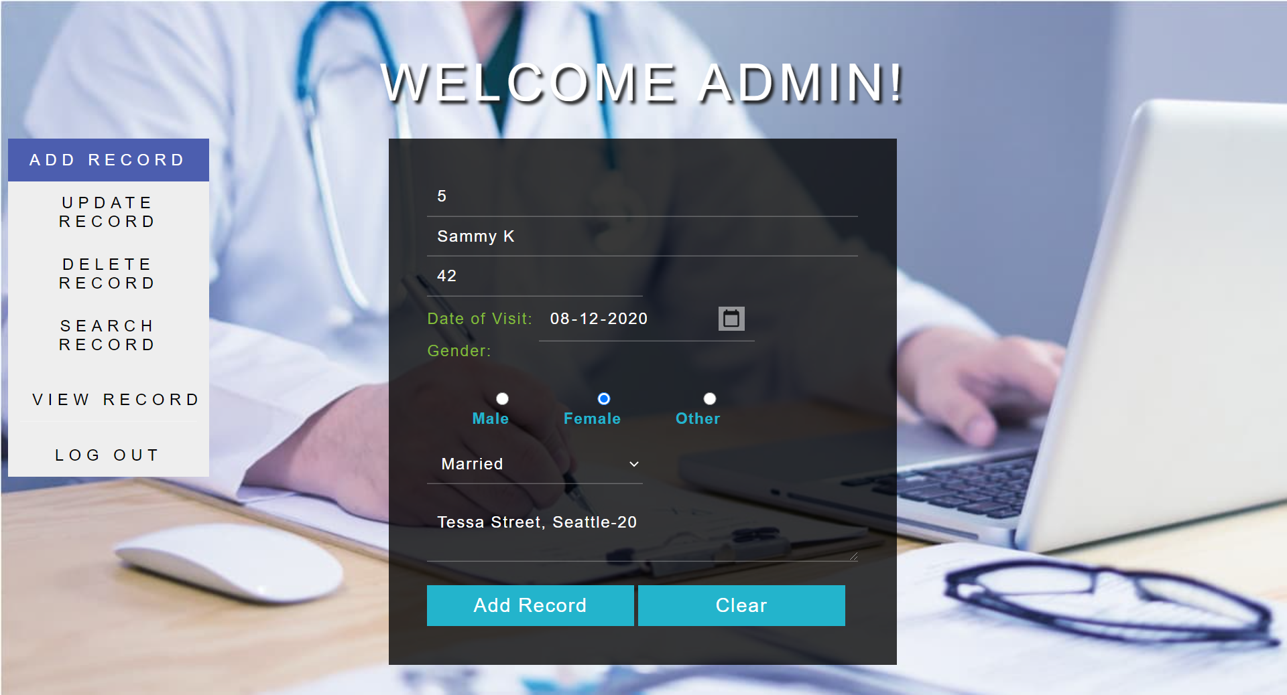

**(If wrong ID is entered)**



**View Page:**

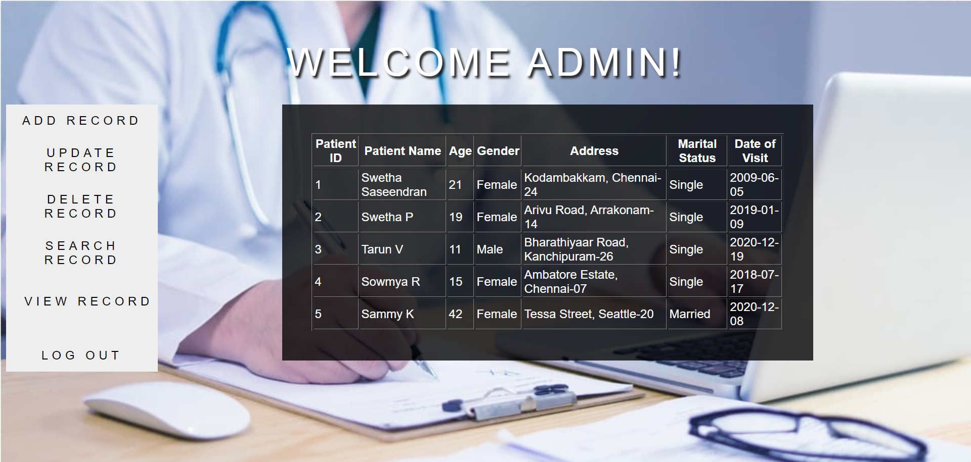

**Search Page:**





**(If invalid ID is entered)**



**Update Record Page:**





**(If invalid ID is entered)**



**(Updating age)**





**View Records:**

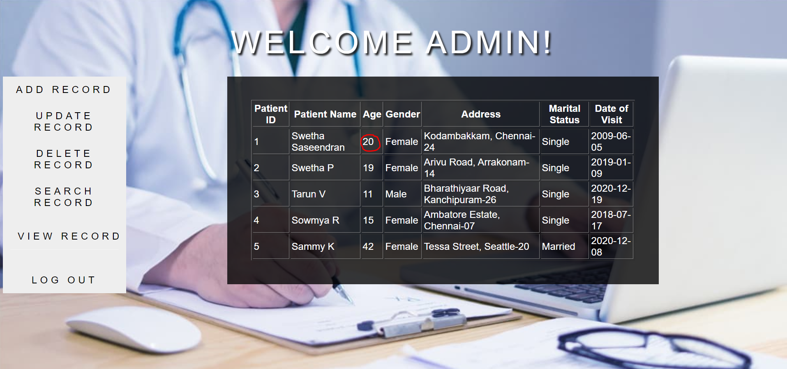

**Delete Page:**



**(If invalid ID is entered)**



**View Page:**

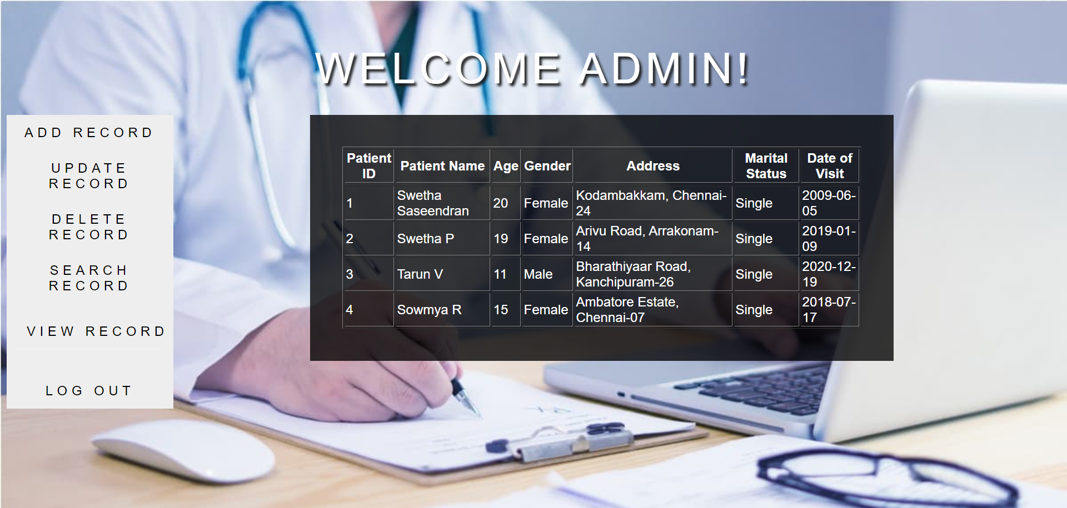

**MySQL Database:**

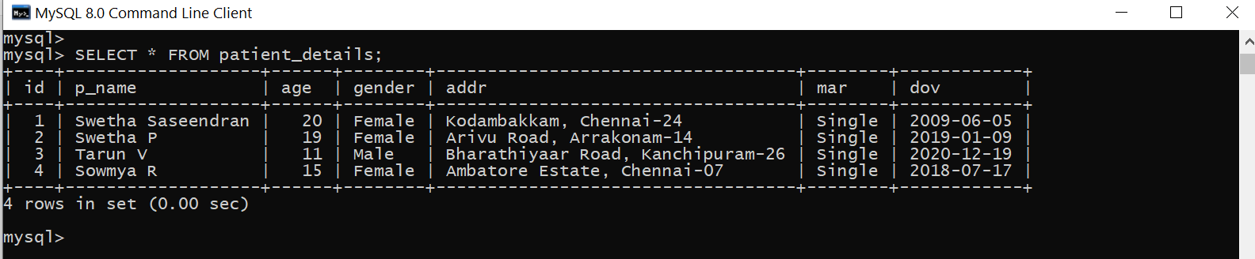

**LEARNING OUTCOME:**

* Learnt to develop interactive web applications using HTML forms and servlets and that servlets are deployed on the server to create dynamic web pages.
* Learnt how to use request and response objects provided to a servlet to read parameters and to produce an HTML response.
* Understood how to use Java exception handling to handle errors in servlet applications.
* Understood the role of JDBC in Java persistence code, and use JDBC for persistence in servlet applications.
* Learnt how to connect to a JDBC-compliant database (MySQL), and manipulate the Patient database and retrieve data from the Patient database to display them in a readable format on HTTP page using the servlet response object.
* Learnt to write query for relational data, and parse result sets and perform updates, inserts and deletes on relational data using SQL actions.
* Understood the importance of making web pages accessible, well-formed and user friendly.